Final Lab CompE375

Objective: The objective of my project was to have 4 buttons with different frequencies corresponding to each one. There would then be a fifth button that would change the corresponding frequency, repeating this 4 times reaching a maximum frequency. Once a certain frequency was pressed that noise would be played and the frequency level would be printed on the LCD screen.

Parts:

* AVR Board
* Auxiliary wire
* USART LED Screen
* 4 regular black buttons
* 1 regular white button
* Wires
* Proto Board
* 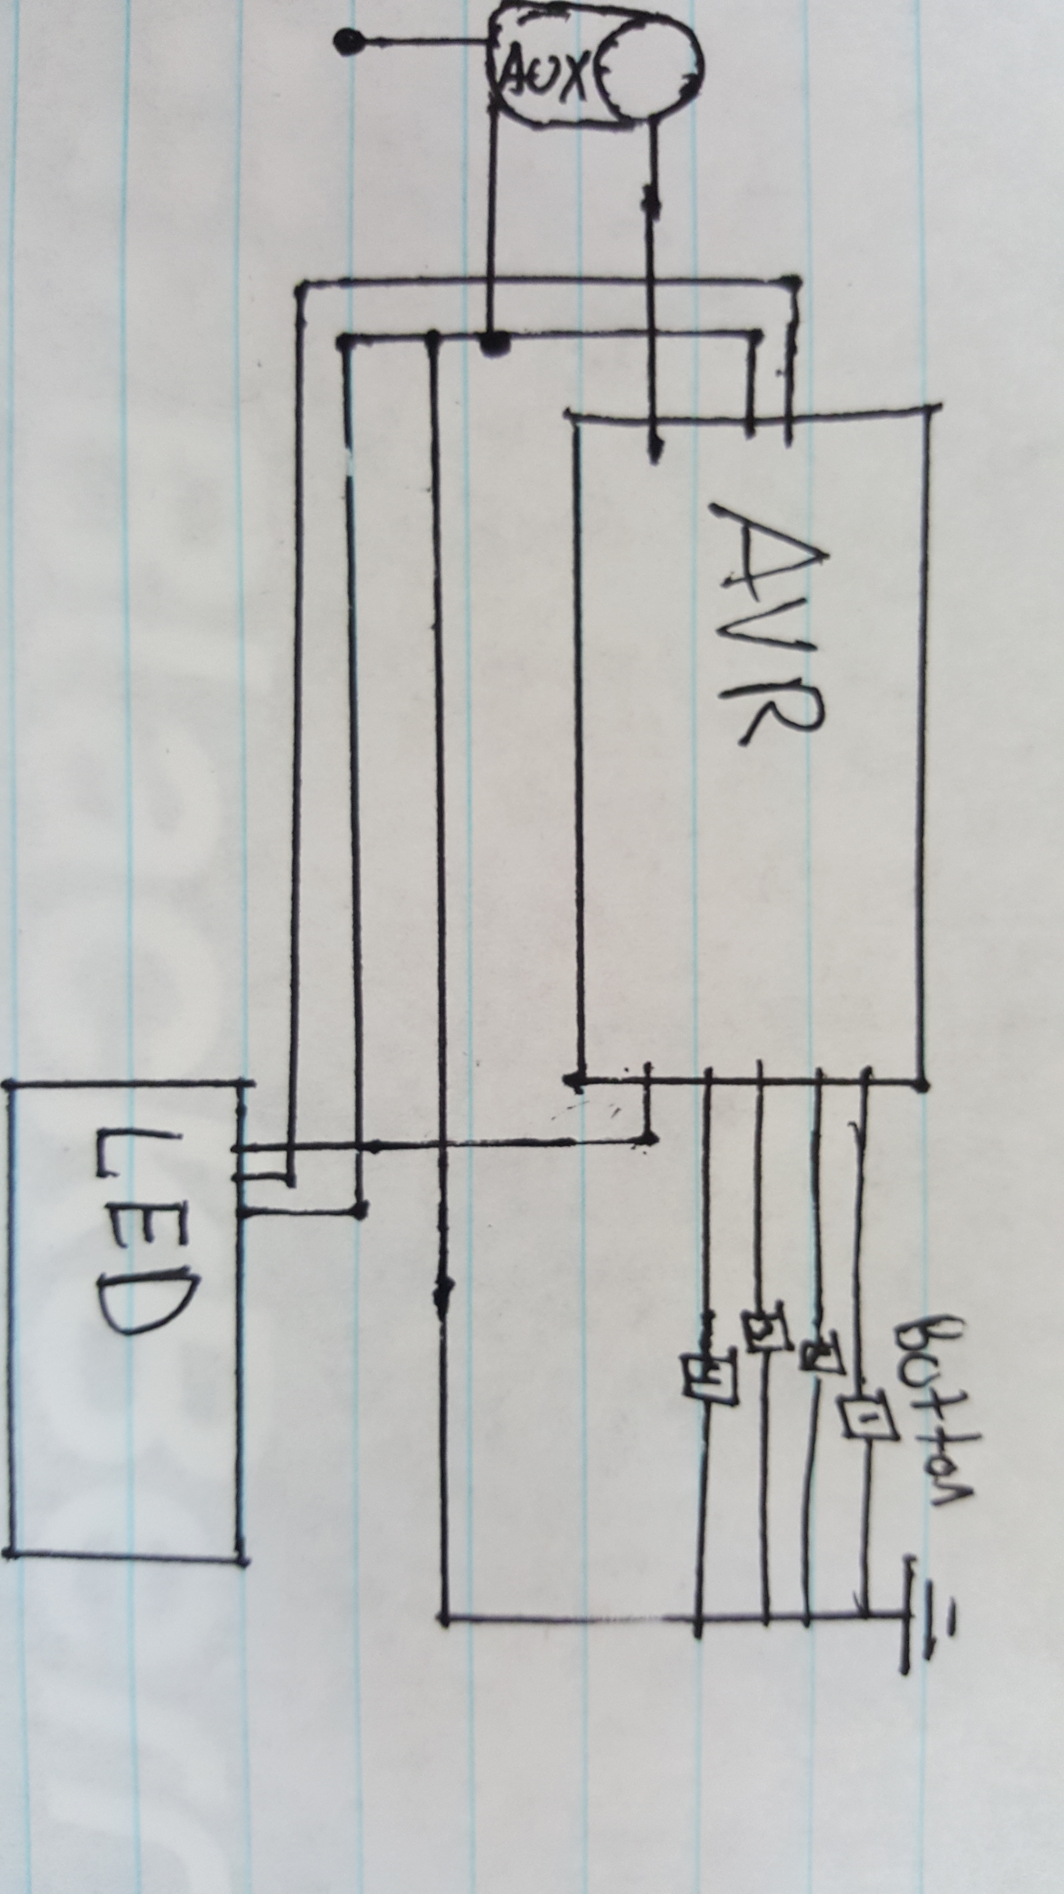USB Wire

Board Layout:

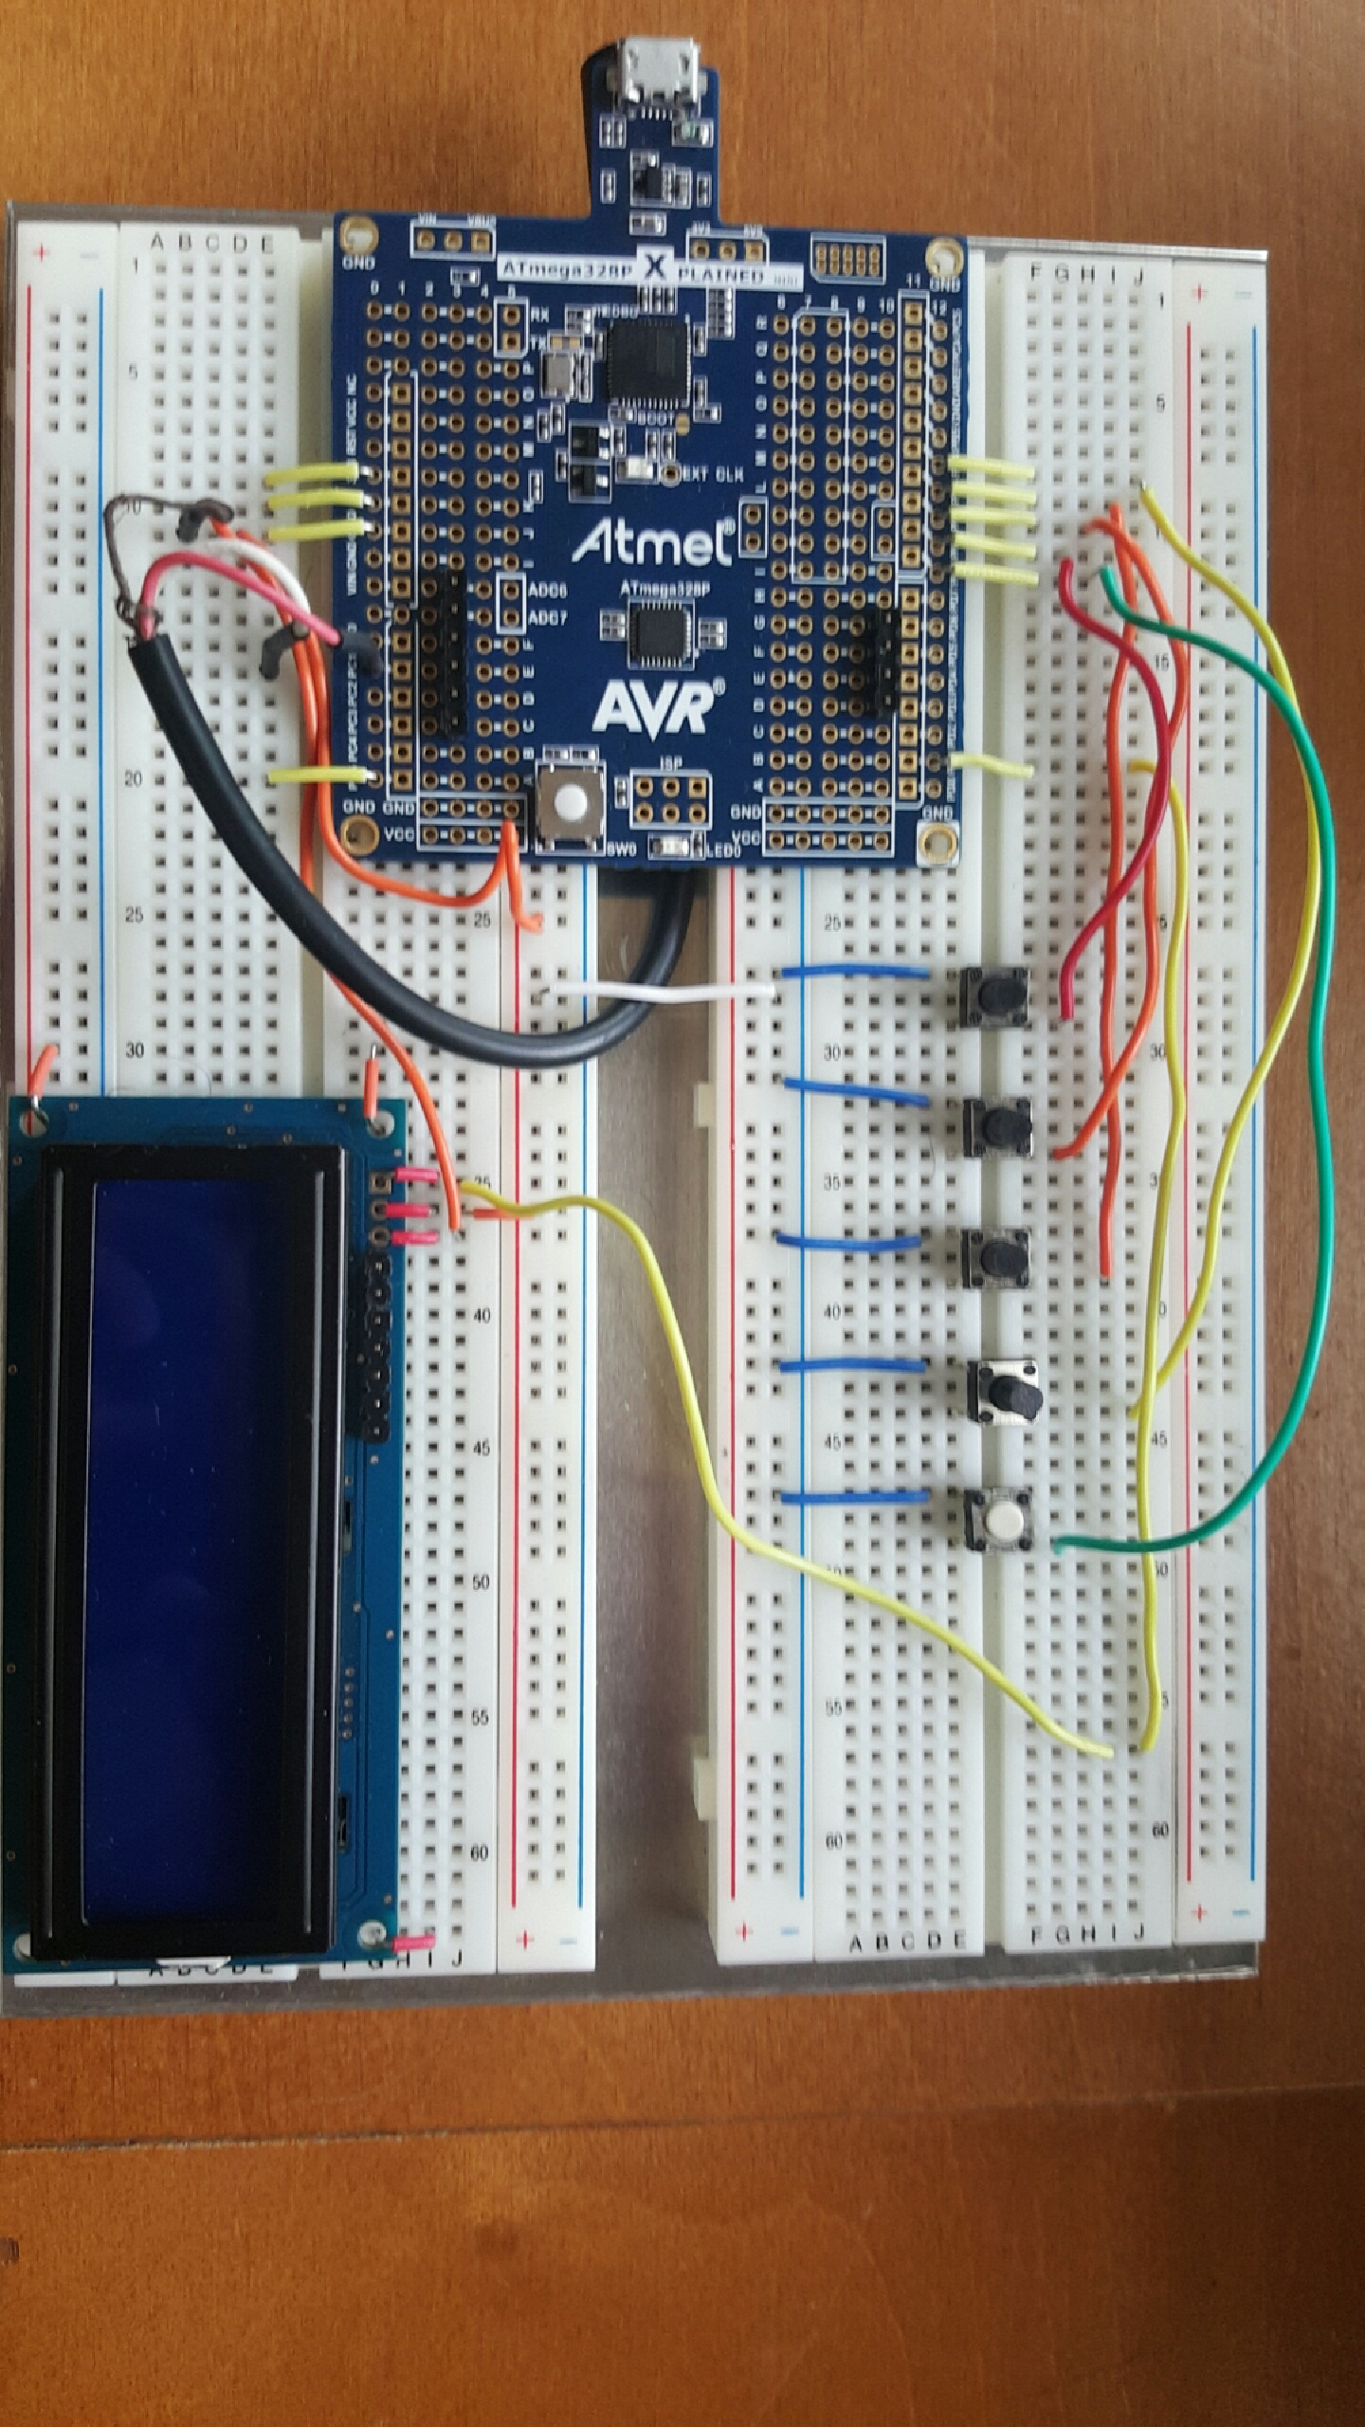

Execution:

I first set up the LED screen I bought for my project. It was a simple LED screen containing 10 pins, however only 3 being of use to me. The three pins that I used were (Rx to receive the signal), (VSS to ground the source) and (VDD to supply a 5V power). I connected everything correspondingly only difference was I attached Rx to the Tx port on the AVR board (PD1). To test this setup I simply transmitted characters to the LED screen having it then print it.

Once such was set up I connected 5 buttons to the Ports (PD0-PD4). The way these buttons were set up was that the pins were set as HIGH inputs. Once the button was pressed it would connected the inner circuit having the voltage reach to ground which was connected on the opposite end of the button. TO test if the buttons were working I simply created and if statement that said if both the pin and port were not in the same state it would transmit a char to the LED screen. Once I saw that was working I went to the next step of creating sound

The last step of the hardware was to attached the auxiliary wire. Similarly from Lab 6 I attached the cord to PC1, Ground and just a metal object. To create sound I calculated the frequency using the formula below.

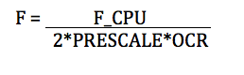

To create the sound I used this new number and set the pin to send out a high voltage for x amount of milliseconds turn it off and then turn it back on for x amount of milliseconds. I would repeat this process quickly 100 times. Once done it would create a square graph image essentially creating noise.

Once everything was finally tested and working I combined all of these attributes together. I had the buttons trigger a certain frequency, once the button as pressed the noise would be imitated and the frequency level would be printed on the screen. It would then wipe the screen ready for the next frequency.

CODE:

#define FOSC 16000000 // Clock Speed #define BAUD 9600

#define BAUD 9600

#define MYUBRR FOSC/16/BAUD-1

#include <avr/io.h>

#include <util/delay.h> // for the delay function

void USART_Transmit( unsigned char data );

unsigned char USART_receive(void);

void change (unsigned char x);

void init (void);

void sound1 (void);

void sound2 (void);

void sound3 (void);

void sound4 (void);

void sound5 (void);

void sound6 (void);

void sound7 (void);

void sound8 (void);

void sound9 (void);

void sound10 (void);

void sound11 (void);

void sound12 (void);

void sound13 (void);

void sound14 (void);

void sound15 (void);

void sound16 (void);

int main(void)

{

int ii;

int n;

int count = 1;

char freq1[] = "Freq=440";

char freq2[] = "Freq=460";

char freq3[] = "Freq=480";

char freq4[] = "Freq=490";

char freq5[] = "#TFM";

char b[] = " ";

init();

USART_putstring(&freq5);

while (1)

{

if(!(PINB & (1<<PINB0)))

{

count = count + 1;

}

if (count == 4)

{

count = 1;

}

if (count = 1)

{

if(!(PINB & (1<<PINB1)))

{

USART_putstring(&freq1);

sound1();

n = 1;

_delay_ms(50);

while (n!=5)

{

for (ii = 0; ii < 37; ii++)

{

USART_putstring(&b);

}

n++;

}

_delay_ms(5000);

}

if(!(PINB & (1<<PINB2)))

{

USART_putstring(&freq2);

sound2();

n = 1;

_delay_ms(50);

while (n!=5)

{

for (ii = 0; ii < 37; ii++)

{

USART_putstring(&b);

}

n++;

}

_delay_ms(5000);

}

if(!(PINB & (1<<PINB3)))

{

USART_putstring(&freq3);

sound3();

n = 1;

_delay_ms(50);

while (n!=5)

{

for (ii = 0; ii < 37; ii++)

{

USART_putstring(&b);

}

n++;

}

_delay_ms(5000);

}

if(!(PINB & (1<<PINB4)))

{

USART_putstring(&freq4);

sound4();

n = 1;

_delay_ms(50);

while (n!=5)

{

for (ii = 0; ii < 37; ii++)

{

USART_putstring(&b);

}

n++;

}

_delay_ms(5000);

}

}

if (count = 2)

{

if(!(PINB & (1<<PINB1)))

{

sound5();

}

if(!(PINB & (1<<PINB2)))

{

sound6();

}

if(!(PINB & (1<<PINB3)))

{

sound7();

}

if(!(PINB & (1<<PINB4)))

{

sound8();

}

}

if (count = 3)

{

if(!(PINB & (1<<PINB1)))

{

sound9();

}

if(!(PINB & (1<<PINB2)))

{

sound10();

}

if(!(PINB & (1<<PINB3)))

{

sound11();

}

if(!(PINB & (1<<PINB4)))

{

sound12();

}

}

if (count = 4)

{

if(!(PINB & (1<<PINB1)))

{

sound13();

}

if(!(PINB & (1<<PINB2)))

{

sound14();

}

if(!(PINB & (1<<PINB3)))

{

sound15();

}

if(!(PINB & (1<<PINB4)))

{

sound16();

}

}

}

}

void USART_Transmit( unsigned char data )

{

while ( !( UCSR0A & (1<<UDRE0)) ); // UDRE0 Is an Empty Flag used to compare the Status data to see if it is empty

UDR0 = data; // If it is not empty it will save data there, outputting it.

}

unsigned char USART_receive(void)

{

while(!(UCSR0A & (1<<RXC0)));

return UDR0;

}

void USART_putstring(unsigned char *SRED)

{

int i, tmp, stop1 = 0;

while (stop1 != 1)

{

if(*(SRED + i) != '\0') // String is not at a NULL

{

tmp = *(SRED +i);

USART_Transmit(tmp); //Send the String value to transmit

_delay_ms(1000);

}

else

{

stop1 = 1;

}

i++;

}

}

void init(void)

{

UBRR0H = (MYUBRR>>8); //Sets the Highest Bit on the USRAT

UBRR0L = MYUBRR; //Sets the Lowest Bit of the USRAT

UCSR0B = (1<<RXEN0)|(1<<TXEN0); // Assigns Transmit and Receive functions as UCSRB functions

UCSR0C =(0<<USBS0) | (1<<UCSZ00)|(1<<UCSZ01); // Assigns one Stop Bit and UCSZ0 as USCRC functions

DDRB = 0b00000000; // DDRB as INPUT

PORTB = 0b00011111; // 1-5 as high

DDRC = 0b11111111;

}

void sound1 ()

{

int i;

for (i =0; i < 10000; i++)

{

PORTB |= (1<<PORTC1);

_delay_ms(.8);

PORTC &= ~(1<<PORTC1);

_delay_ms(.8);

}

}

void sound2 ()

{

int i;

for (i =0; i < 10000; i++)

{

PORTC |= (1<<PORTC1);

_delay_ms(.85);

PORTC &= ~(1<<PORTC1);

_delay_ms(.85);

}

}

void sound3 ()

{

int i;

for (i =0; i < 10000; i++)

{

PORTC |= (1<<PORTC1);

_delay_ms(.9);

PORTC &= ~(1<<PORTC1);

_delay_ms(.9);

}

}

void sound4 ()

{

int i;

for (i =0; i < 10000; i++)

{

PORTC |= (1<<PORTC1);

_delay_ms(0.95);

PORTC &= ~(1<<PORTC1);

_delay_ms(0.95);

}

}

void sound5 ()

{

int i;

for (i =0; i < 100; i++)

{

PORTC |= (1<<PORTC1);

_delay_ms(1.0);

PORTC &= ~(1<<PORTC1);

_delay_ms(1.0);

}

}

void sound6 ()

{

int i;

for (i =0; i < 100; i++)

{

PORTC |= (1<<PORTC1);

_delay_ms(1.05);

PORTC &= ~(1<<PORTC1);

_delay_ms(1.05);

}

}

void sound7 ()

{

int i;

for (i =0; i < 100; i++)

{

PORTC |= (1<<PORTC1);

_delay_ms(1.1);

PORTC &= ~(1<<PORTC1);

_delay_ms(1.1);

}

}

void sound8 ()

{

int i;

for (i =0; i < 100; i++)

{

PORTC |= (1<<PORTC1);

_delay_ms(1.15);

PORTB &= ~(1<<PORTC1);

_delay_ms(1.15);

}

}

void sound9 ()

{

int i;

for (i =0; i < 100; i++)

{

PORTC |= (1<<PORTC1);

_delay_ms(1.2);

PORTC &= ~(1<<PORTC1);

_delay_ms(1.2);

}

}

void sound10 ()

{

int i;

for (i =0; i < 100; i++)

{

PORTC |= (1<<PORTC1);

_delay_ms(1.25);

PORTC &= ~(1<<PORTC1);

_delay_ms(1.25);

}

}

void sound11 ()

{

int i;

for (i =0; i < 100; i++)

{

PORTC |= (1<<PORTC1);

_delay_ms(1.30);

PORTC &= ~(1<<PORTC1);

_delay_ms(1.30);

}

}

void sound12 ()

{

int i;

for (i =0; i < 100; i++)

{

PORTC |= (1<<PORTC1);

_delay_ms(1.35);

PORTC &= ~(1<<PORTC1);

_delay_ms(1.35);

}

}

void sound13 ()

{

int i;

for (i =0; i < 100; i++)

{

PORTC |= (1<<PORTC1);

_delay_ms(1.40);

PORTC &= ~(1<<PORTC1);

_delay_ms(1.40);

}

}

void sound14 ()

{

int i;

for (i =0; i < 100; i++)

{

PORTC |= (1<<PORTC1);

_delay_ms(1.45);

PORTC &= ~(1<<PORTC1);

_delay_ms(1.45);

}

}

void sound15 ()

{

int i;

for (i =0; i < 100; i++)

{

PORTC |= (1<<PORTC1);

_delay_ms(1.50);

PORTC &= ~(1<<PORTC1);

_delay_ms(1.50);

}

}

void sound16 ()

{

int i;

for (i =0; i < 100; i++)

{

PORTC |= (1<<PORTC1);

_delay_ms(1.55);

PORTC &= ~(1<<PORTC1);

_delay_ms(1.55);

}

}